**Medical Inventory**

**Management**

|  |  |
| --- | --- |
| **Date** | 27/06/2025 |
| **Team ID** | LTVIP2025TMID31079 |
| **Project Name** | Medical Inventory Management |
| **College name** | IDEAL INSTITUTE OF TECHNOLOGY, KAKINADA |

**Team Leader:** Prem Narasimha Murthy Yandamuri

**Team member:** Palaparthi Tanmai Sreelakshmi Jayachandra

**Team member:** Parimi Lakshmi Tulasi

**Team member:** O Maneendra Venkata Gangadhar Siva

**1.Introduction:**

# Project Overview:

The Medical Inventory Management System is a digital solution designed to streamline the tracking, management, and reporting of medical supplies within healthcare facilities. It helps healthcare providers maintain accurate inventory records, monitor stock levels in real-time, and receive automatic alerts for low stock and expiring medicines.

By replacing manual processes with an automated system, the project aims to minimize human errors, reduce stock shortages, prevent wastage from expired products, and improve the overall efficiency of inventory management. The system will support role-based access for various users like pharmacists, doctors, and administrators, ensuring secure and efficient handling of inventory data. Key features include barcode scanning, real-time stock updates, expiry alerts, detailed reporting, and a user-friendly interface accessible across devices.

This project is a comprehensive Salesforce application to streamline and manage various operational aspects of medical inventory. The system aims to efficiently maintain supplier details, manage purchase orders, track product details and transactions, and monitor the expiry dates of products. Maintain detailed records of suppliers, including contact information. Catalog product information, including descriptions, stock levels. Monitor and track product expiry dates to avoid using expired items. Comprehensive reports to track supplier performance, and purchase orders.

# Purpose:

The purpose of the Medical Inventory Management System is to provide healthcare facilities with an efficient, automated solution for managing medical supplies and inventory. This system is intended to:

* Ensure accurate tracking of medical stock levels in real-time.
* Prevent stock outs of essential medicines and supplies.
* Reduce wastage by identifying and managing expired items promptly.
* Enhance decision-making through accurate inventory reports and analytic.
* Streamline procurement by providing timely alerts for restocking.
* Improve patient safety by ensuring the availability of required medicines at all times.

Ultimately, the project aims to improve the operational efficiency of healthcare facilities and contribute to better healthcare service delivery.

**2.Ideation Phase**

# Brainstorming:

In Medical Inventory Management project, prioritizing the quantity of ideas over their initial feasibility is key—even unconventional or out-of-the-box solutions are highly encouraged. These ideas can be refined and built upon by the team to develop robust, scalable, and efficient Salesforce-based solutions.

# Empathy Map:

The empathy map focuses on understanding the key needs and challenges faced by medical inventory managers, pharmacists, and hospital staff who use the system.

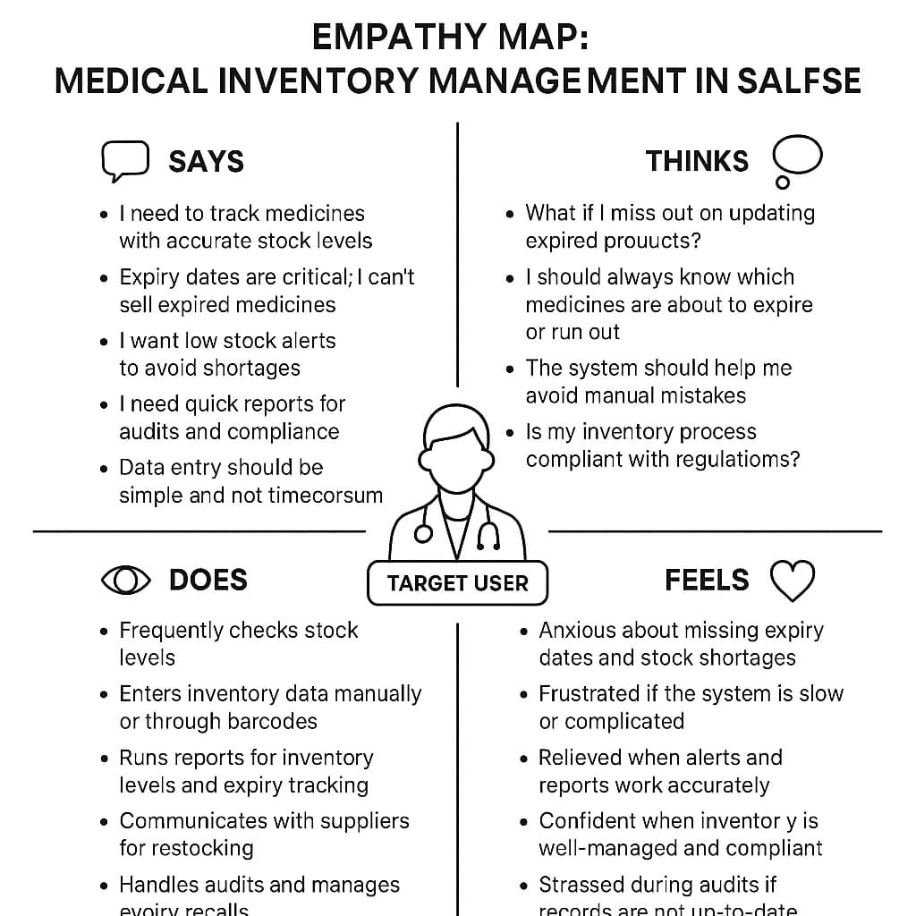

* Says: Users emphasize the need for accurate stock tracking, expiry date management, low stock alerts, quick reporting, and simple data entry.
* Thinks: They worry about missing expiry updates, making manual mistakes, and ensuring regulatory compliance.
* Does: Users frequently monitor stock, update inventories, run reports, communicate with suppliers, and manage audits.
* Feels: They often feel anxious about shortages, frustrated by complicated systems, relieved when alerts function correctly, and confident when inventory is well-managed.

This map helps align the Salesforce solution to address user pains, improve efficiency, and enhance user satisfaction.

# Problem Statement:

While developing a medical inventory management system in the Salesforce developer platform, challenges often arise in creating accurate and efficient reports due to complex data relationships, limited report customization, and manual data handling. These issues can lead to incomplete inventory visibility, delayed expiry tracking, and missed stock alerts, ultimately affecting decision-making, regulatory compliance, and patient safety. There is a need for streamlined, automated, and real-time reporting solutions within Salesforce to ensure accurate tracking, timely notifications, and effective inventory management.

**3. Requirement Analysis:**

# Customer Journey map:

The customer journey map outlines the key stages a medical inventory user, such as a pharmacist or hospital staff, experiences while interacting with the Salesforce-based inventory management system. It tracks the user’s journey from initial awareness to long-term system adoption and highlights their actions, thoughts, feelings, and touchpoints at each step.

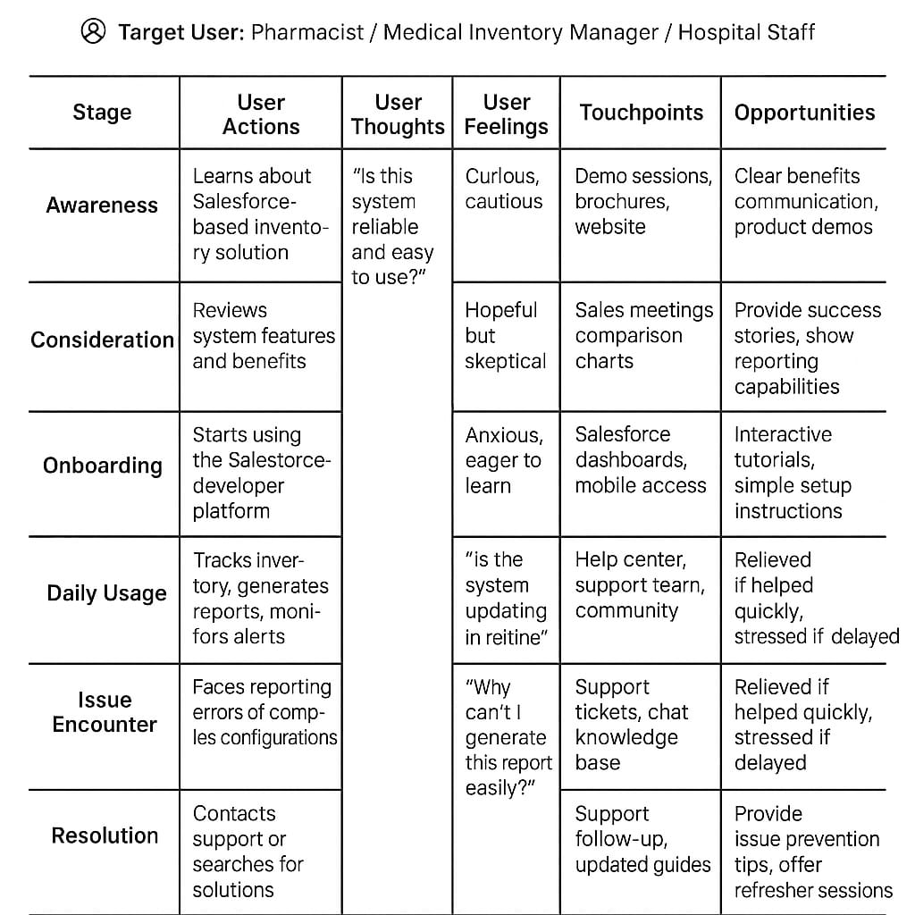

The map identifies crucial moments such as:

* Awareness and Consideration: Users explore the system’s benefits and evaluate its ability to solve their inventory challenges.
* Onboarding and Daily Usage: Users begin using the system, focusing on inventory tracking and reporting, while dealing with initial learning curves.
* Issue Encounter and Resolution: Users face reporting challenges and rely on support for timely solutions, directly impacting their satisfaction.
* Loyalty: Satisfied users may advocate for the system when their pain points are consistently addressed.

The map emphasizes the importance of simple onboarding, real-time reporting, quick support, and continuous system improvements to ensure user satisfaction and system efficiency

# Solution Requirements:

For the Medical Inventory Management Project in Salesforce, the solution requirements can be divided into two major categories:

1. Functional Requirements:

* Real-time inventory tracking with batch and expiry management.
* Automated alerts for low stock and upcoming expiries.
* Custom, real-time reporting (inventory, expiry, audit).
* Quick data entry with barcode support.
* Role-based user access (manager, staff, auditor).
* Workflow automation for restocking and expiry management.
* Mobile access for inventory updates and reporting.
* Optional integration with supplier systems.

1. Non-Functional Requirements:

* Fast system performance and real-time updates.
* User-friendly interface requiring minimal training.
* Scalable to handle growing inventory and users.
* High system reliability with minimal downtime.
* Strong security with role-based access and data protection.
* Easy maintenance and system updates.

# Technology Stack:

Technology Stack for Medical Inventory Management in Salesforce

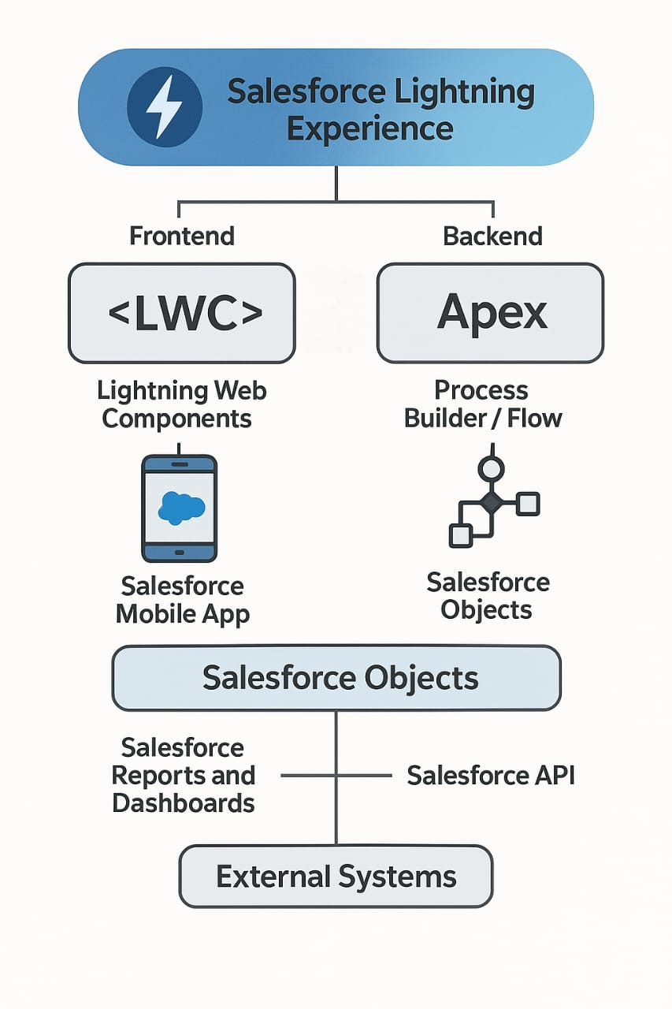

1. User Interface:

* Salesforce Lightning Experience
* Modern UI for easy navigation and customization.
* Lightning Web Components (LWC)
* For building custom, fast, and responsive components.
* Salesforce Mobile App
* For mobile inventory management access.

2. Server-side Processing:

* Apex
  + Salesforce’s proprietary programming language for custom logic, triggers, and automation.
* Process Builder / Flow
  + For automating workflows like restock alerts, expiry warnings.
* Salesforce Reports and Dashboards
  + For real-time data visualization and inventory reporting.

3. Database:

* Salesforce Objects (Standard & Custom): Stores medical inventory data, stock levels, expiry dates, etc.

4. Integration Tools (if needed):

* Salesforce API (REST/SOAP): For integration with external supplier or hospital management systems.

# Data Flow Diagram:

**4.Project Desing:**

# Problem Solution Fit:

Problem:

Healthcare facilities often face:

* Stock shortages.
* Expired medicines going unnoticed.
* Manual tracking errors.
* Inefficient inventory reporting.

Solution:

A Medical Inventory Management System that:

* Tracks stock levels in real-time.
* Sends automated alerts for low stock and nearing expiry.
* Provides accurate reporting and analytic.
* Reduces manual errors with bar code scanning and digital records.

Problem-Solution Fit:

You achieve fit when:

* Healthcare staff find the system easy to use and it saves their time.
* Expiry alerts reduce medicine wastage.
* Stock shortage incidents drop significantly.
* Decision-makers trust the reports and use them for ordering and planning.

Problem-Solution Fit is when medical inventory system genuinely solves the pain points of medicine tracking, stock management, and reporting in healthcare settings, and the users (like pharmacists, nurses, and admins) are happy with the solution.

# Proposed Solution:

The Medical Inventory Management System is a smart, digital solution designed to address the common challenges faced by healthcare facilities in managing their medical supplies. Traditional manual tracking methods often lead to stock shortages, unnoticed expiry dates, and reporting errors that can impact patient safety and hospital efficiency. This system offers real-time inventory tracking with automated alerts for low stock and upcoming expires, ensuring timely replenishment and reducing wastage. It integrates bar code scanning to speed up inventory updates and minimize manual entry errors.

A user-friendly interface makes it simple for healthcare staff, including pharmacists, nurses, and inventory managers, to use the system with minimal training. It also provides detailed reporting and analytics, helping administrators make quick, data-driven decisions regarding procurement and inventory levels. The system supports multi-user access with role-based permissions, ensuring that each user interacts with the system according to their responsibilities. This enhances data security and workflow efficiency.

By digitizing the inventory process, the proposed solution significantly improves accuracy, reduces human error, and helps maintain a safe and well-stocked medical supply chain in healthcare facilities.

# Solution Architecture:

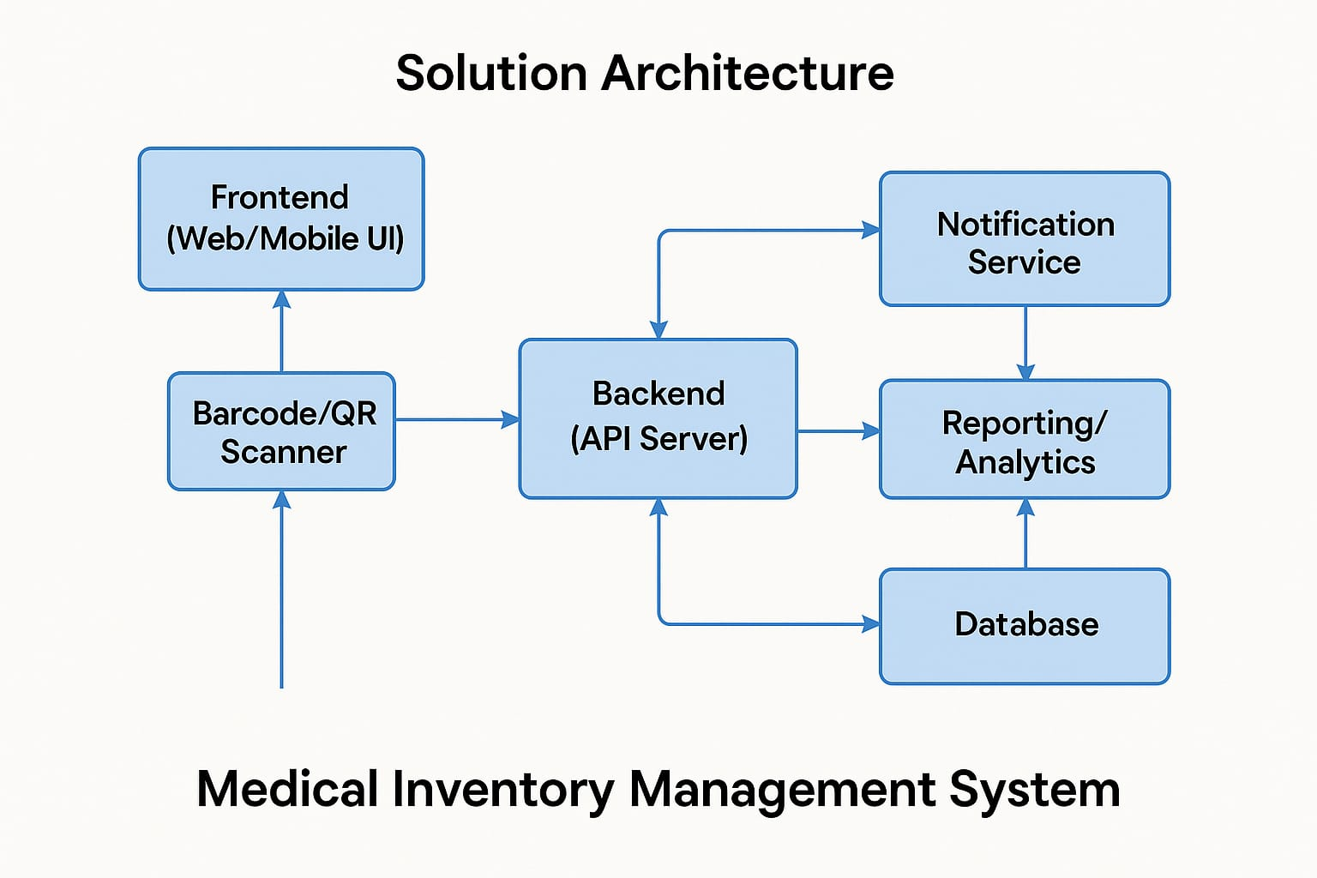

The solution architecture of the Medical Inventory Management System is designed to ensure seamless, secure, and real-time management of medical inventories across healthcare facilities. It is structured into three main layers:

1. Frontend Layer:

The user interface is accessible via both web and mobile applications, providing role-based dashboards for pharmacists, doctors, and administrators. It allows users to view stock levels, receive alerts, and generate reports in a user-friendly environment.

2. Backend Layer:

The backend consists of a Restful API server that manages business logic, inventory operations, and user authentication. It handles all communication between the frontend and the database and integrates services like email and SMS notifications for timely stock and expiry alerts.

3. Database Layer:

The database securely stores all medical inventory data, including stock details, expiry dates, user roles, and transaction logs. It supports real-time updates and retrievals to ensure accuracy and quick response times.

**5.Project Planning & Scheduling**

# Project Planning:

* Initiation:
* Creating a developer org in salesforce.
* On the signup form, entered the details.
* After Activating the account, we will be having the developer account to create the project.

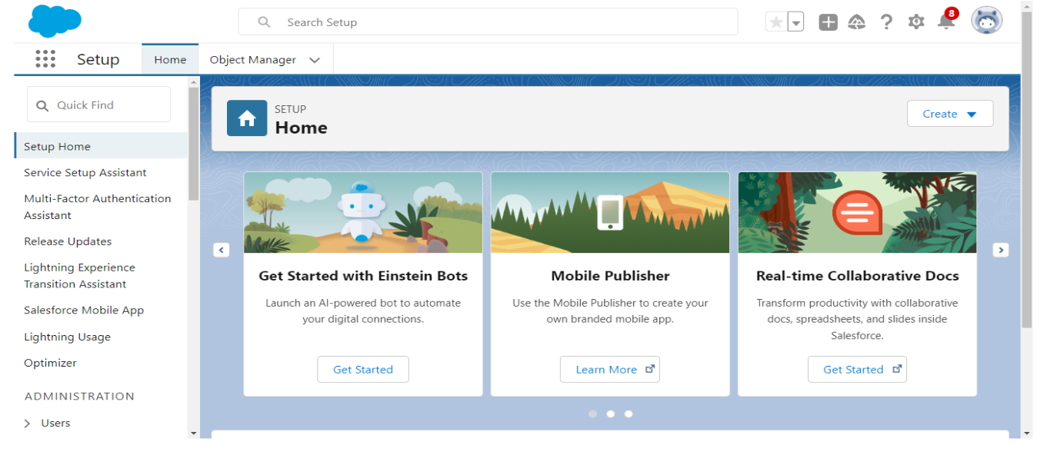

* Planning:
* Creating a Product, Purchase Order, Order Item, Inventory Transaction and Supplier objects.
* Creating tabs for the Objects Created before.
* Created a Lightning App for Medical Inventory Management.
* Creating Fields in the Objects Created before.
* Editing of Page layouts.
* Creating Compact Layouts in required objects.
* Creating validation rules to the employee object.
* Creating Profiles, Users, Roles, Permission sets, Triggers, Reports, dashboards and Flows.
* Development:

Creation of Objects:

To create custom object, go to setup from the directed salesforce home page. Click on Object manager then select new then Custom Object. Fill the details and Create the object. Using the same process we need to create the remaining objects as per the instructions.

We Have created the following objects:

* Product
* Purchase Order
* Order Item
* Inventory Transaction
* Supplier

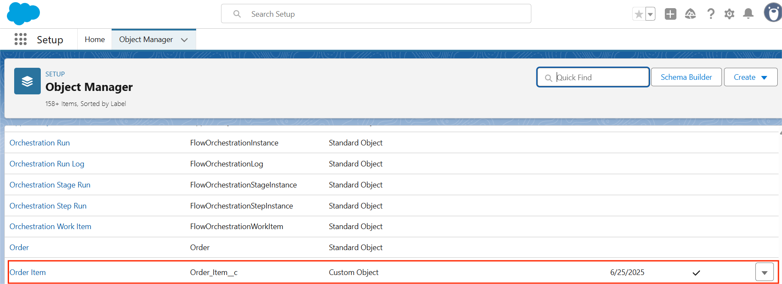











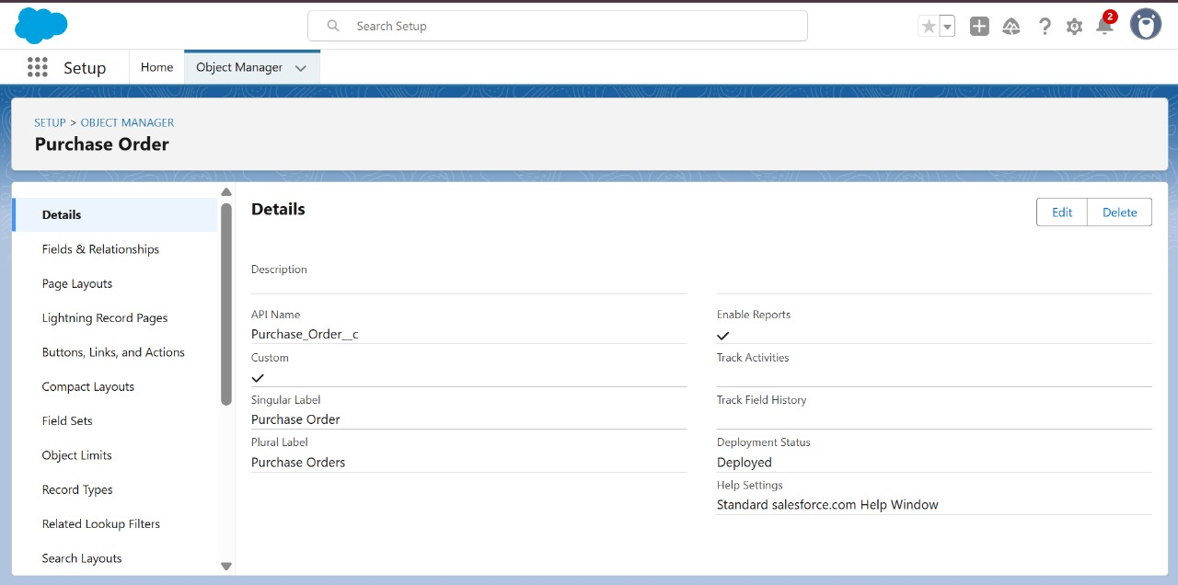

Creation of Tabs:

Tabs are used to make the data stored in objects accessible to users through the user interface. Tabs are a fundamental part of the Salesforce interface, providing a way to navigate to different objects and records.

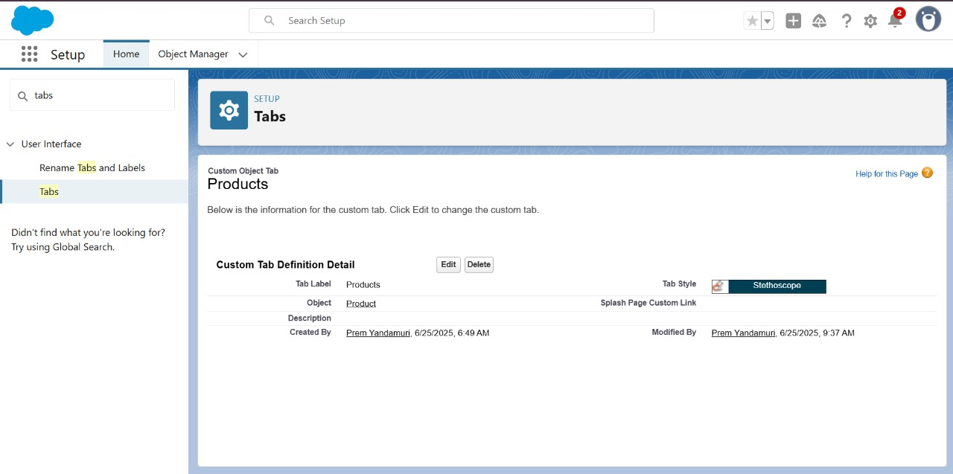

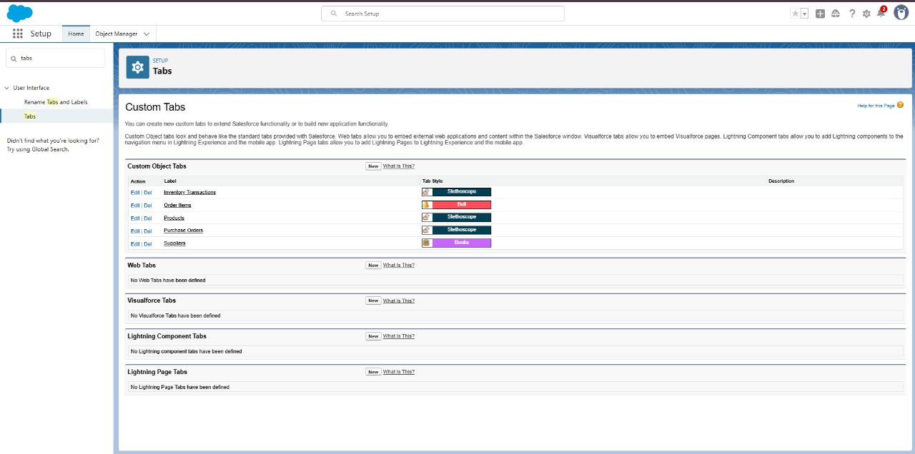

Creating the Lightning App:

A Lightning App in Salesforce is a collection of items that work together to serve a particular function for the end-users. These items can include standard and custom objects, tabs, utilities, and other productivity tools. Lightning Apps are designed to provide a more intuitive and efficient user experience compared to traditional Salesforce apps.

From Setup, enter App Manager in the Quick Find and select App Manager. Click New Lightning App. Enter Medical Inventory Management as the App Name.

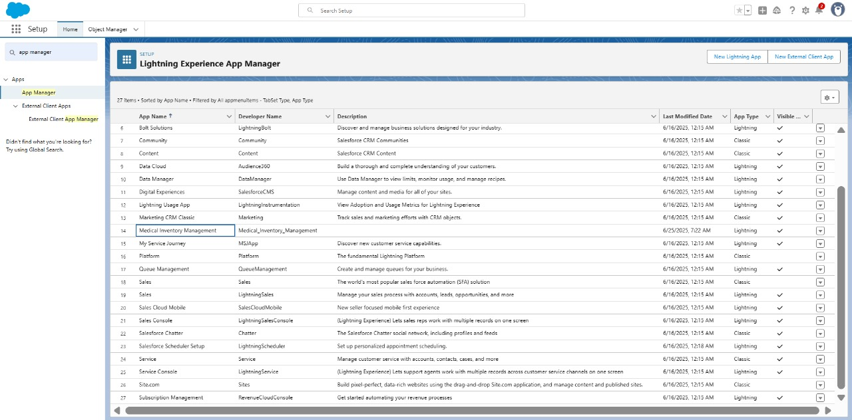

**Creating Fields in Objects:**

**Creating a Text Field in Product Object:**

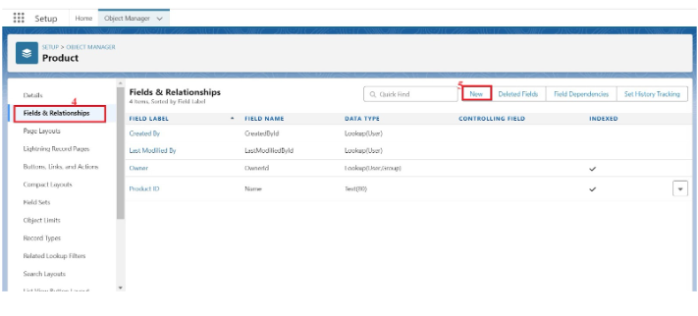

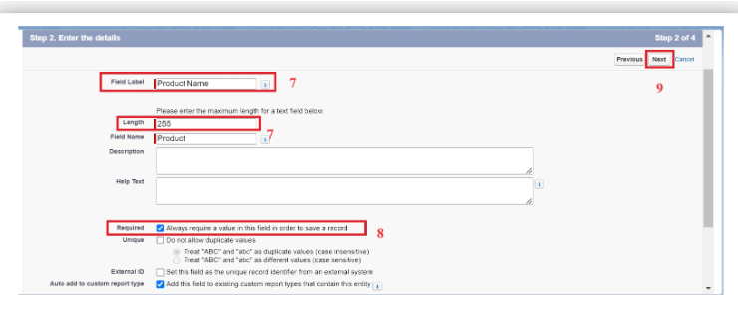

**Creating a Text area Field in Product Object:**

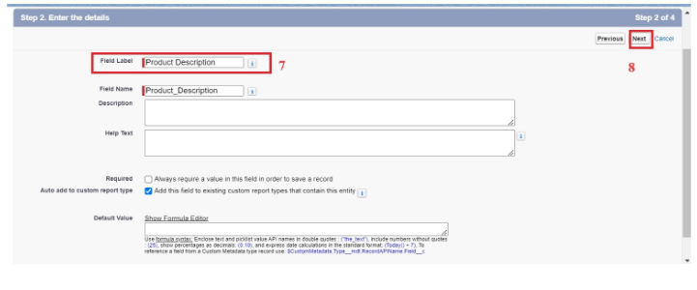

**Created fields in Product Object:**

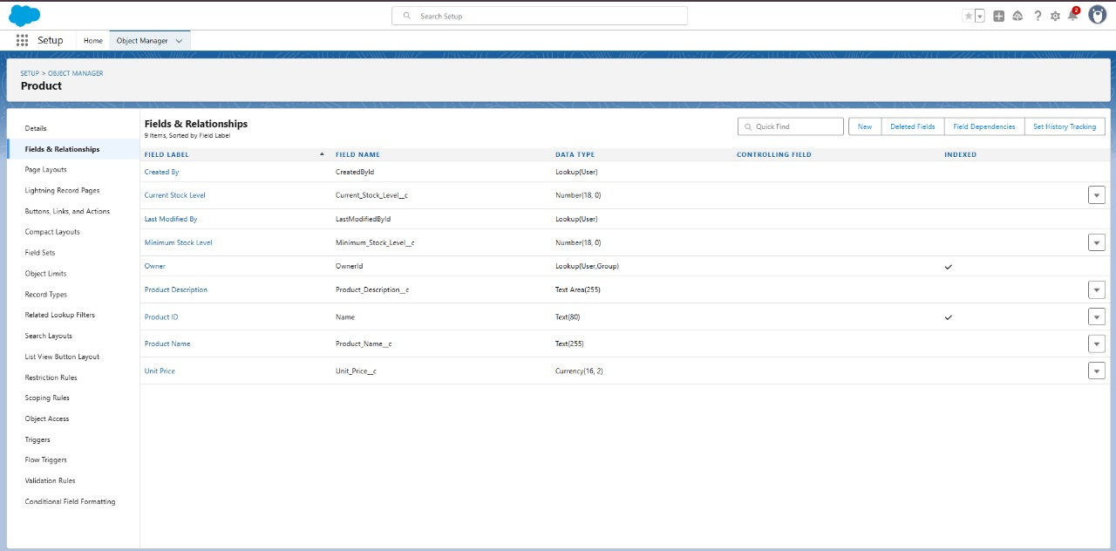

**Creating Lookup Relationship in Purchase Order Object:**

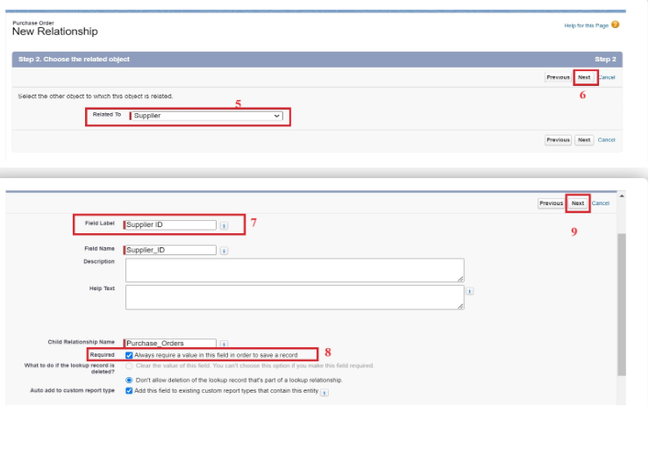

**Created Fields in Purchase Order Object:**

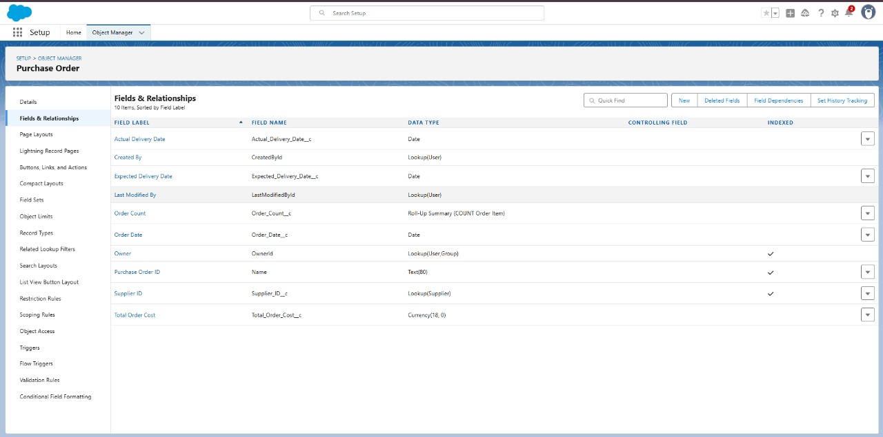

**Creating a Unit Price Formula Field in Order Item object:**

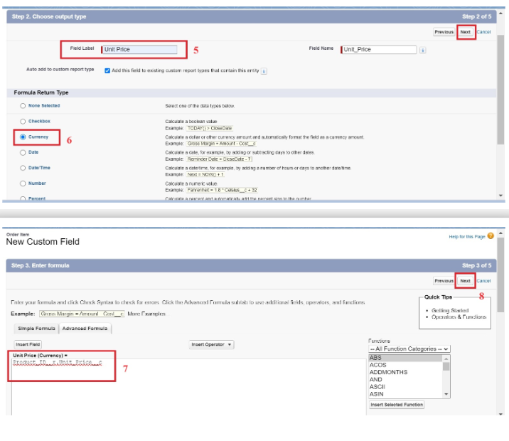

**Created Fields in Order Item Object:**

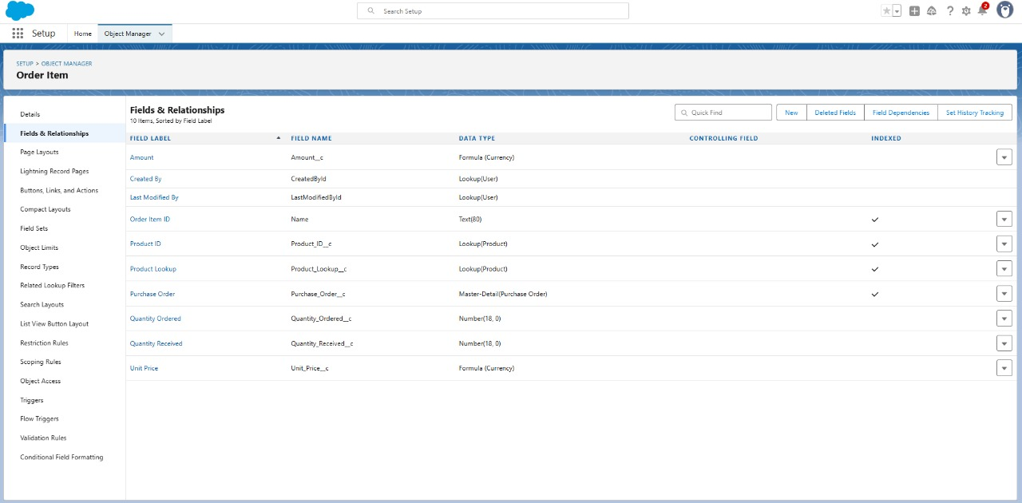

**Created Fields in Inventory Transaction Object:**

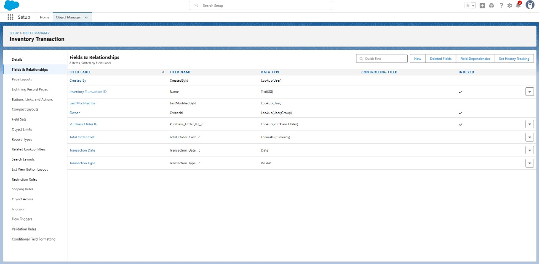

**Created Fields in Supplier Object:**

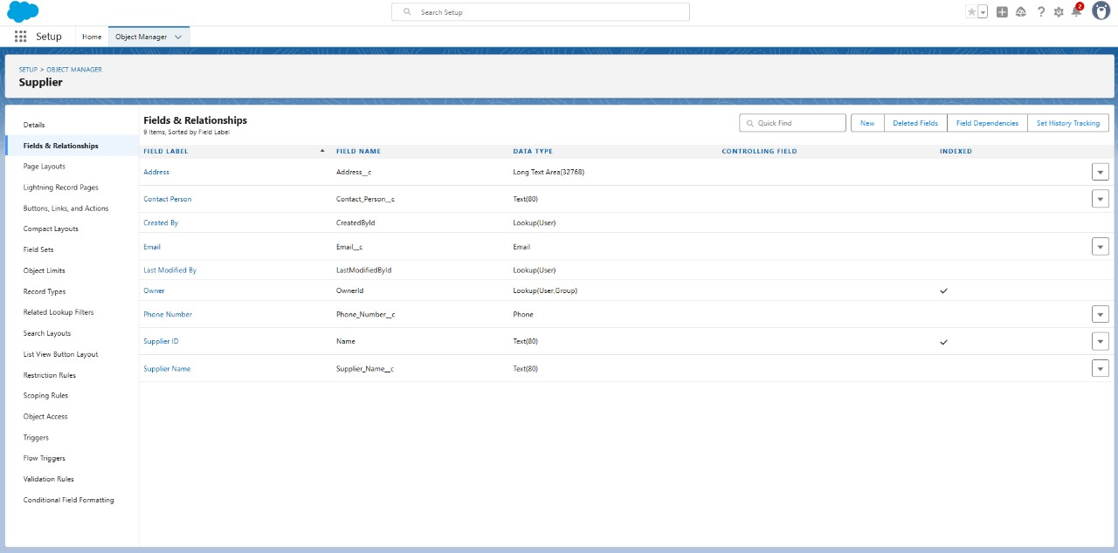

**Creating page layouts in Created objects:**

**Created Page layout in Product object:**

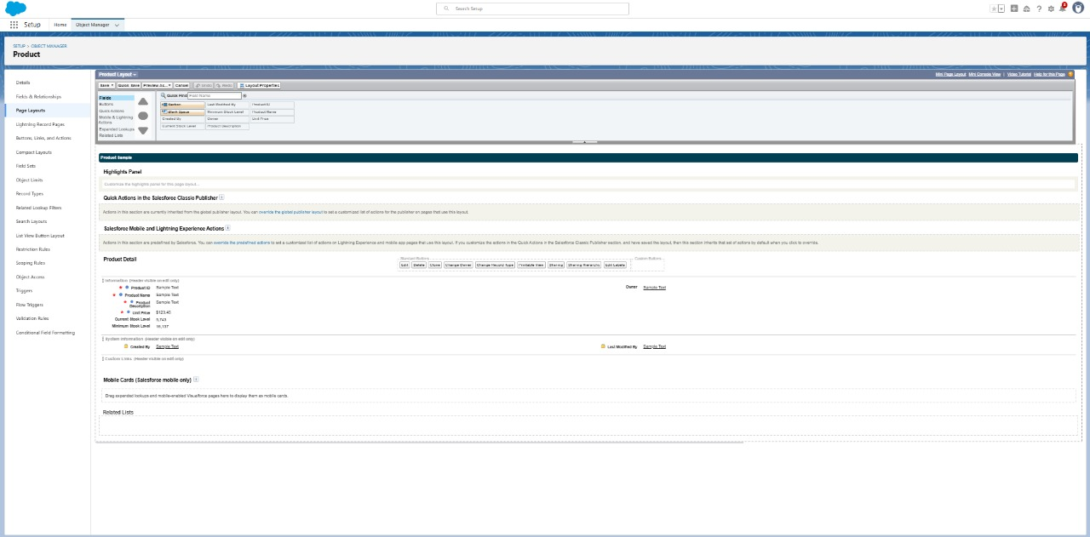

**Created Page layout in Order Item object:**

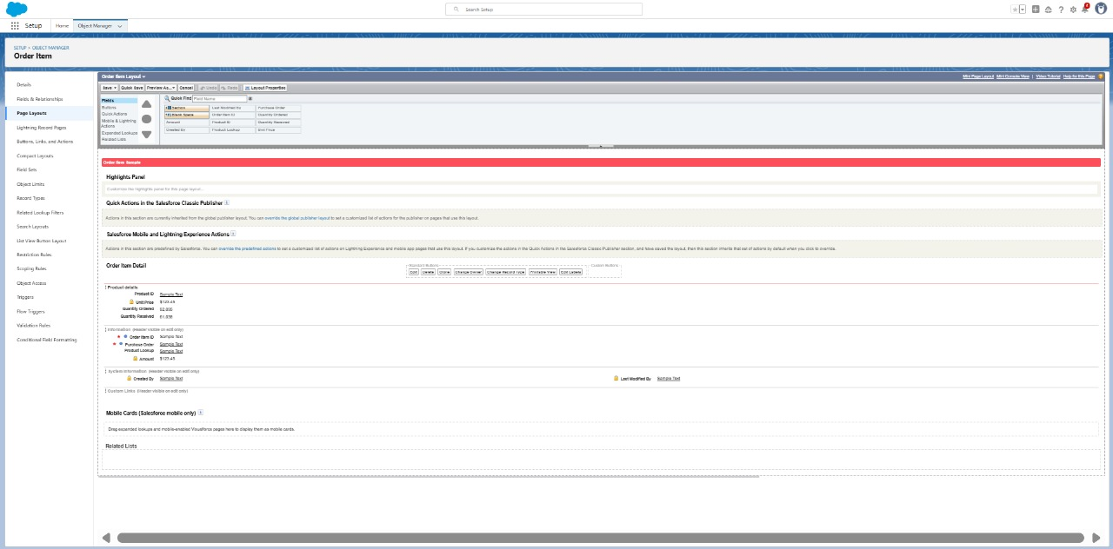

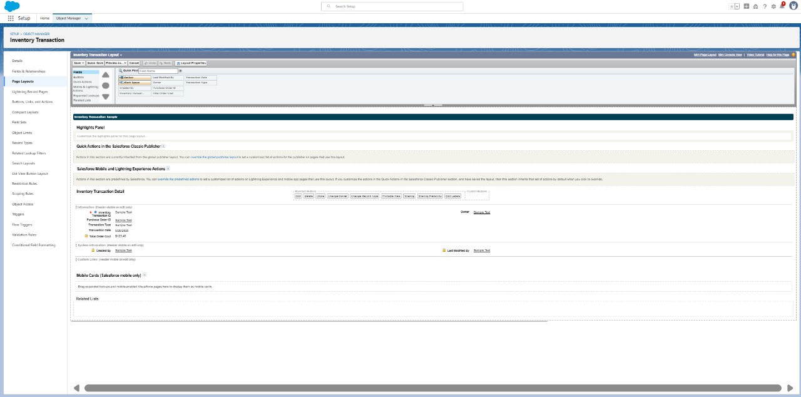 **Created Page layout in Inventory Transaction object:**

**Created Page layout in Supplier object:**

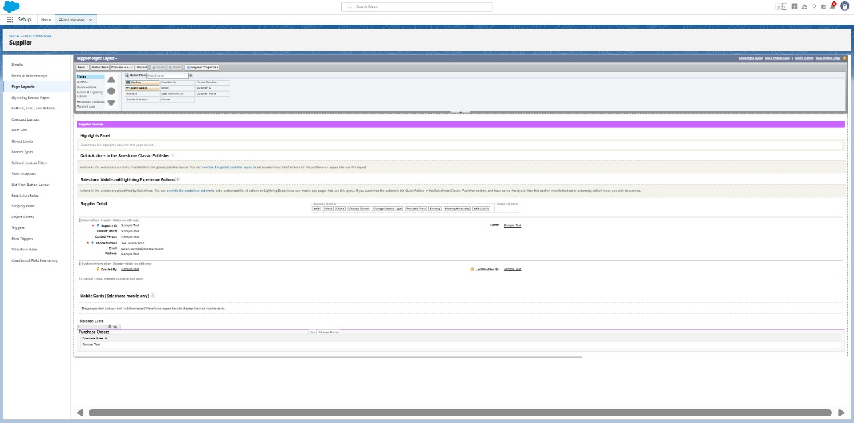

**Compact Layouts:**

Compact layouts display a record’s key fields at a glance, providing important information quickly without needing to open the record.

**Created Compact layout in Product object:**

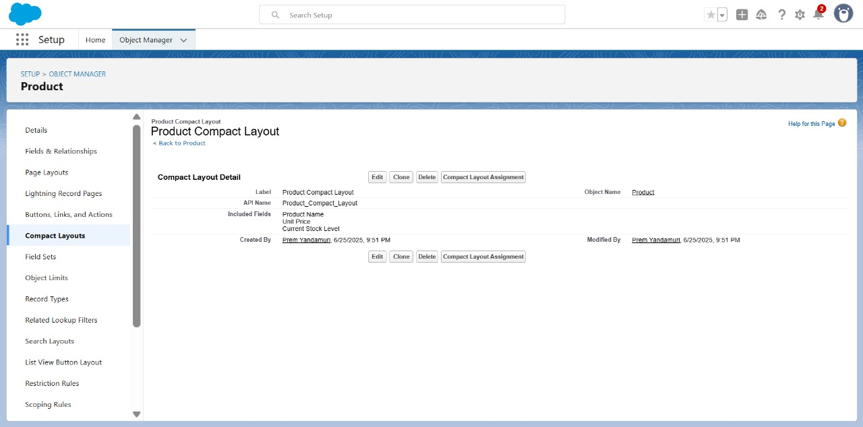

**Created Compact layout in Purchase Order object:**

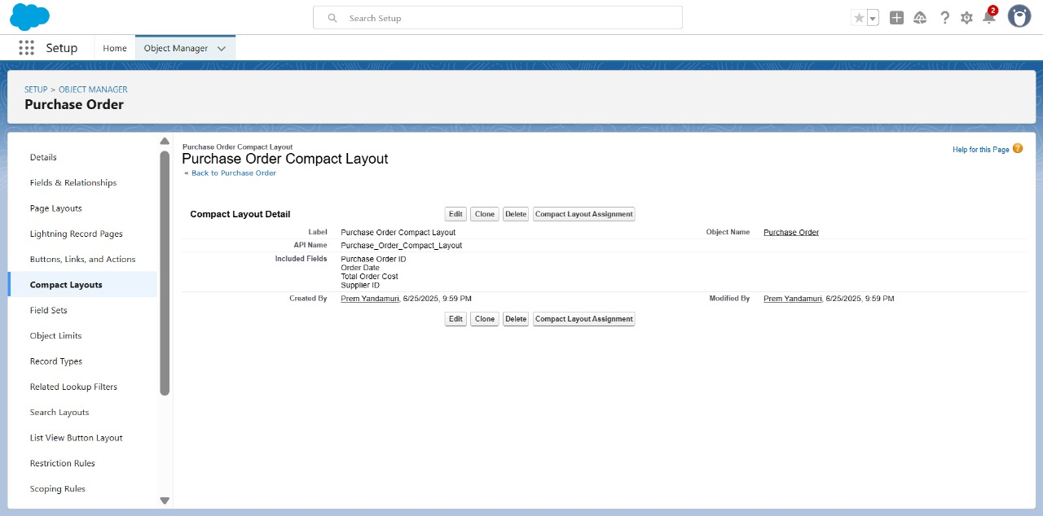

**creating an Expected Delivery Date Validation rule to Employee Object:**

Validation rules in Salesforce are used to ensure data integrity by preventing users from saving invalid data in records. They consist of a formula or expression that evaluates the data in one or more fields and return a value of true or false. When the rule's criteria are met (i.e., the expression evaluates to true), an error message is displayed, and the user is prevented from saving the record until the issue is resolved.

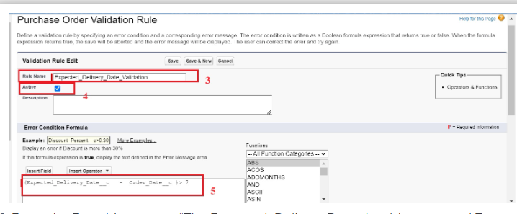

**Created Validation Rule in Purchase Order object:**

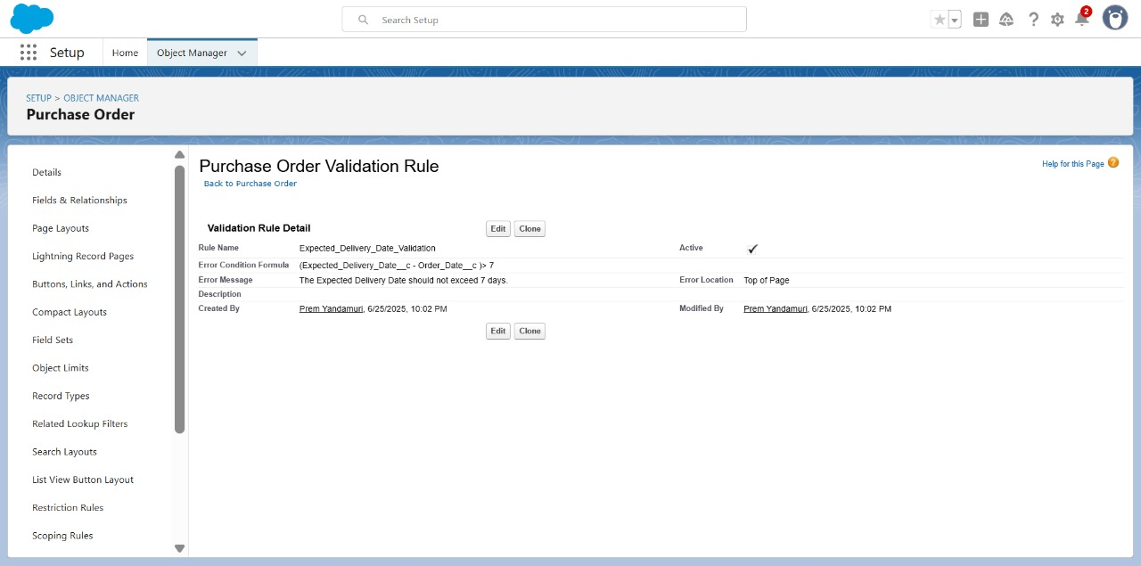

**Profiles:**

Profiles in Salesforce are fundamental to the platform's security model, defining what users can do within the organization. Profiles control a user’s permissions to objects, fields, tabs, apps, and other settings. Each user in Salesforce must be assigned a profile, and the profile assigned to a user determines what they can see and do in the system.

**Created Profiles:**

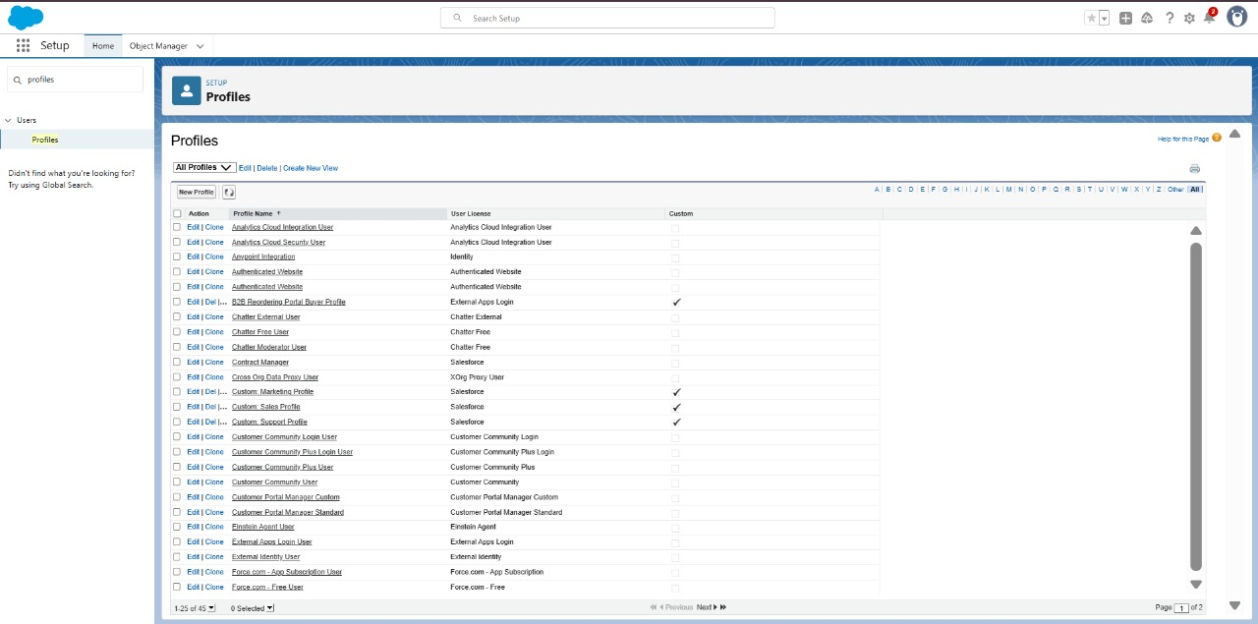

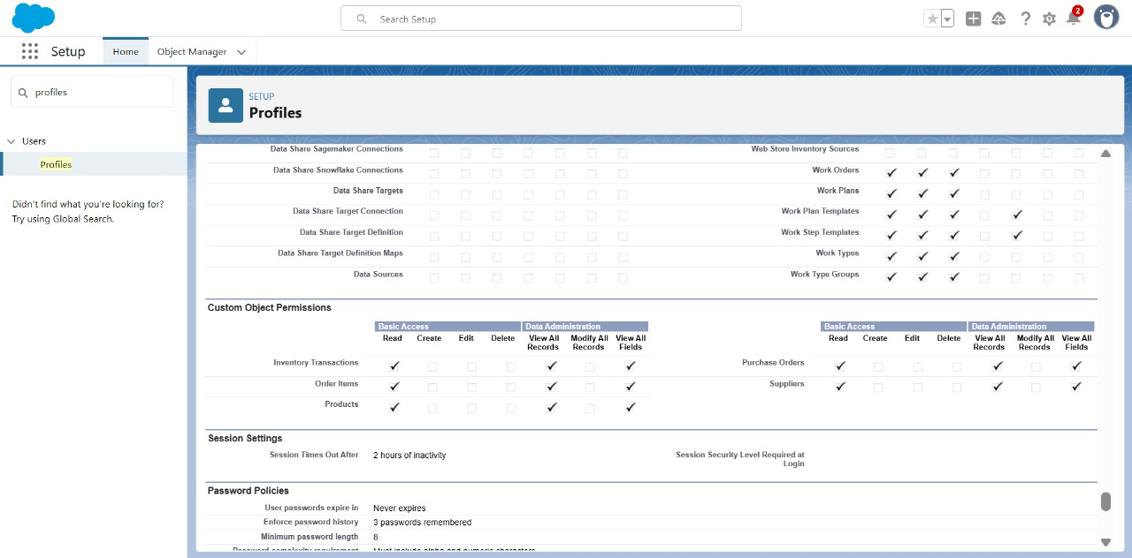

**Roles:**

Roles in Salesforce are used to control record-level access and define the hierarchy of an organization, determining the level of visibility and sharing of records among users. Roles work in conjunction with profiles to provide a robust security model. While profiles control what actions users can perform (object and field permissions), roles control which records users can see based on their position in the hierarchy.

**Created Roles:**

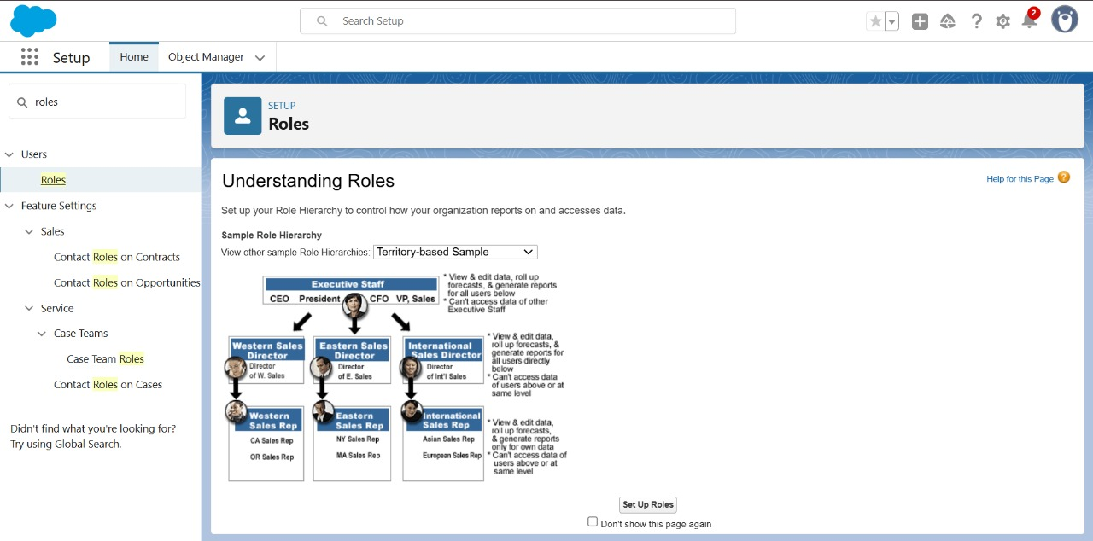

**Users:**

Users in Salesforce are individuals who have access to the Salesforce organization. Each user is assigned a profile that defines their permissions, and they can be assigned to one or more roles within the role hierarchy to determine their access to records. Users can have additional configurations such as permissions sets, licenses, and other settings that further define their capabilities within Salesforce.

**Created Users:**

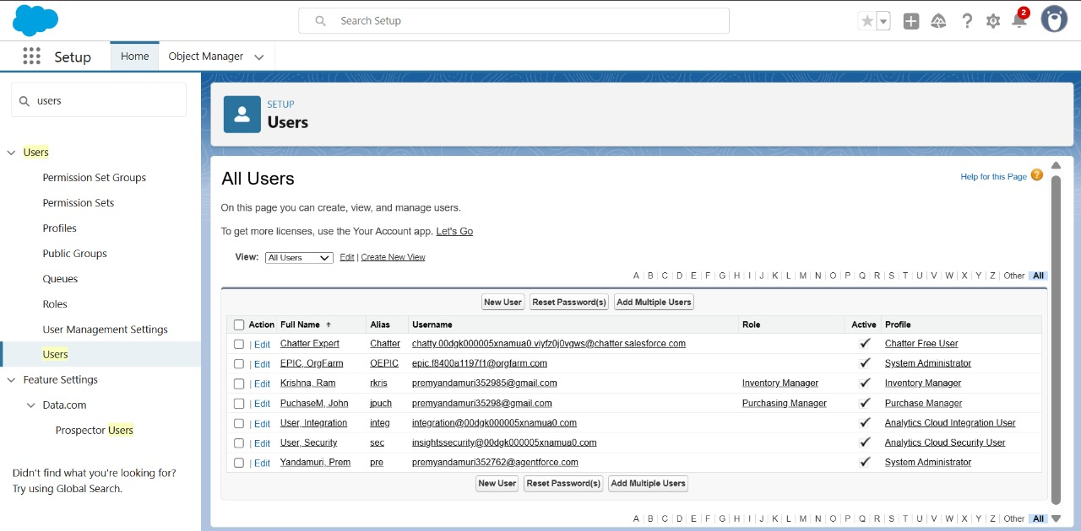

**Permission Sets:**

Permission Sets in Salesforce are a powerful tool to extend user permissions beyond what is defined in their profiles. They allow administrators to grant additional access to various tools and functions without altering the user's profile. Permission sets are particularly useful for providing specialized permissions to specific users without the need to create multiple profiles.

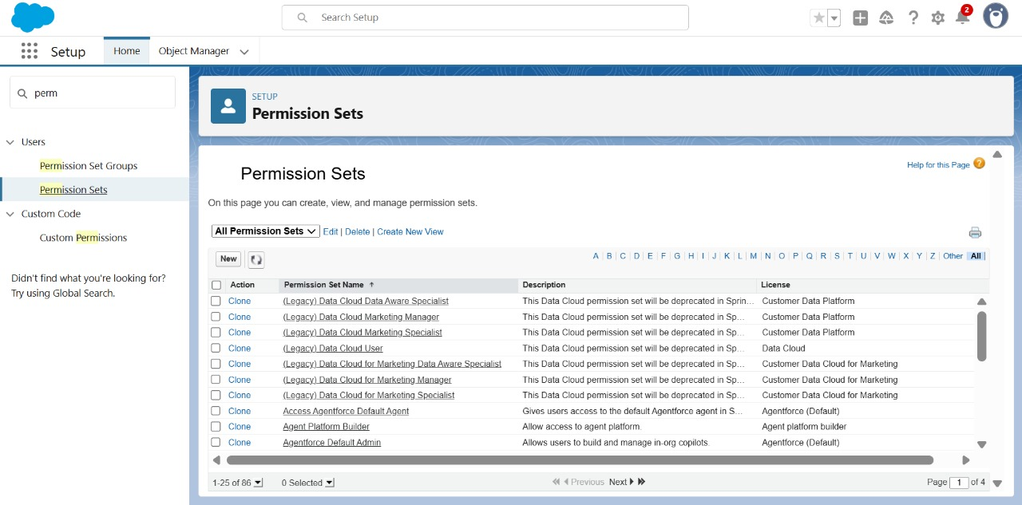

**Created Permission set:**

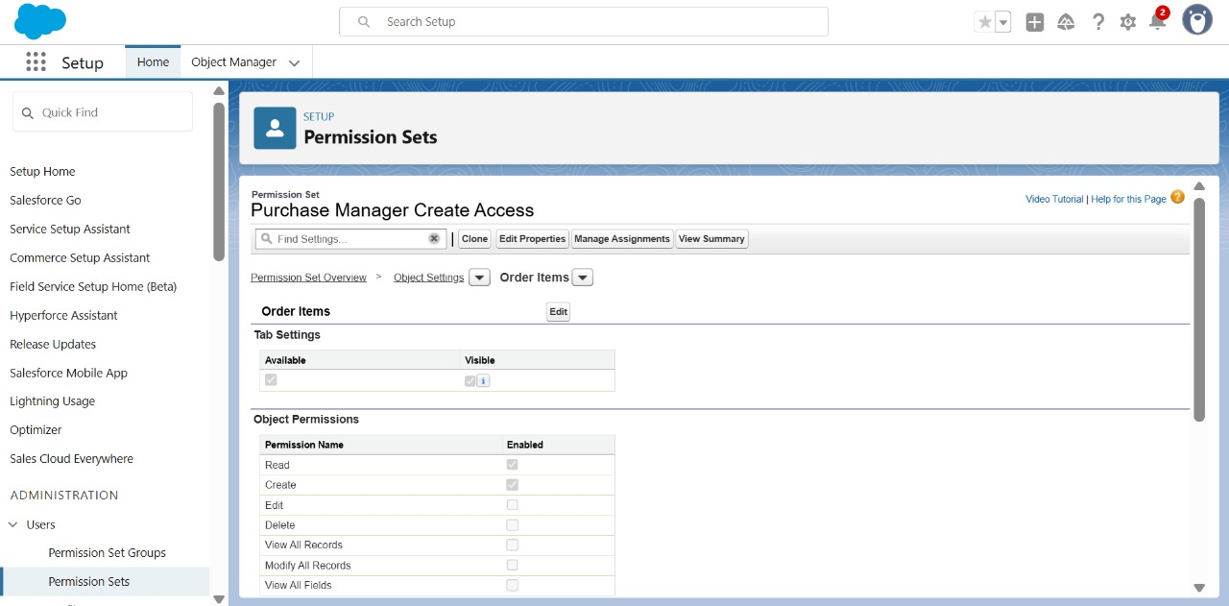

**Flows:**

Flows in Salesforce, part of the Lightning Flow product, are powerful automation tools that help you collect data and perform actions in your Salesforce environment. Flows can be used to automate business processes, guide users through tasks, and integrate with external systems. They are highly versatile and can be configured to meet a wide range of business requirements without the need for custom code.

**Created Flow to update the Actual Delivery Date:**

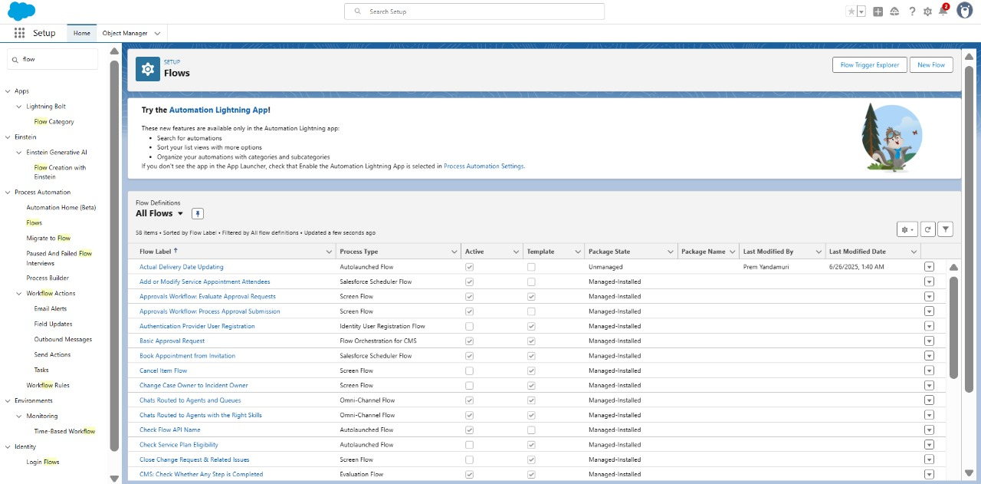

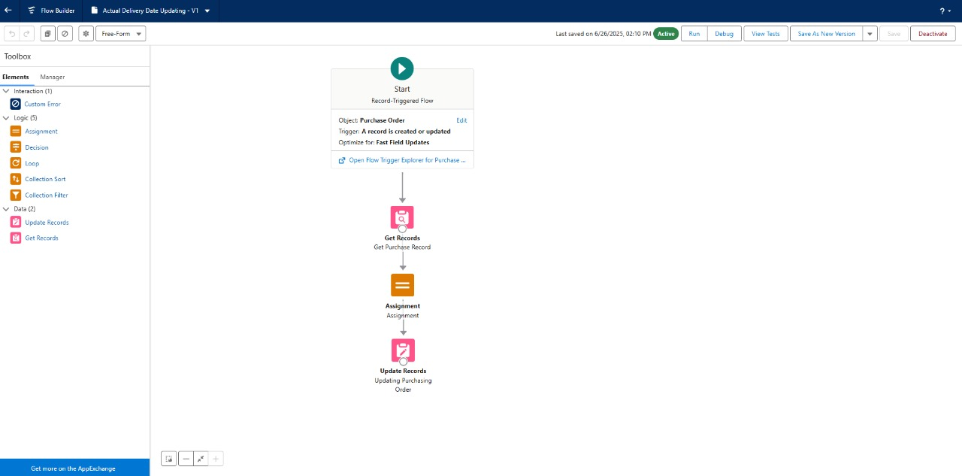

**Triggers:**

Triggers in Salesforce are pieces of Apex code that execute before or after specific data manipulation events on Salesforce records, such as insertions, updates, deletions, and undeletions. They are powerful tools for automating complex business logic and ensuring data integrity by enforcing custom validation rules and workflows that cannot be achieved through declarative tools alone.

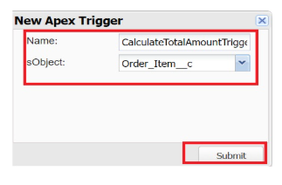 **Created a Trigger to Calculate total amount on Order Item:**

**Reports:**

Reports in Salesforce provide a powerful way to visualize and analyze data stored in your Salesforce organization. They allow users to create, customize, and share different types of reports based on data from standard and custom objects. Reports help organizations make informed decisions by providing insights into key metrics, trends, and performance indicators.

**Created Reports:**

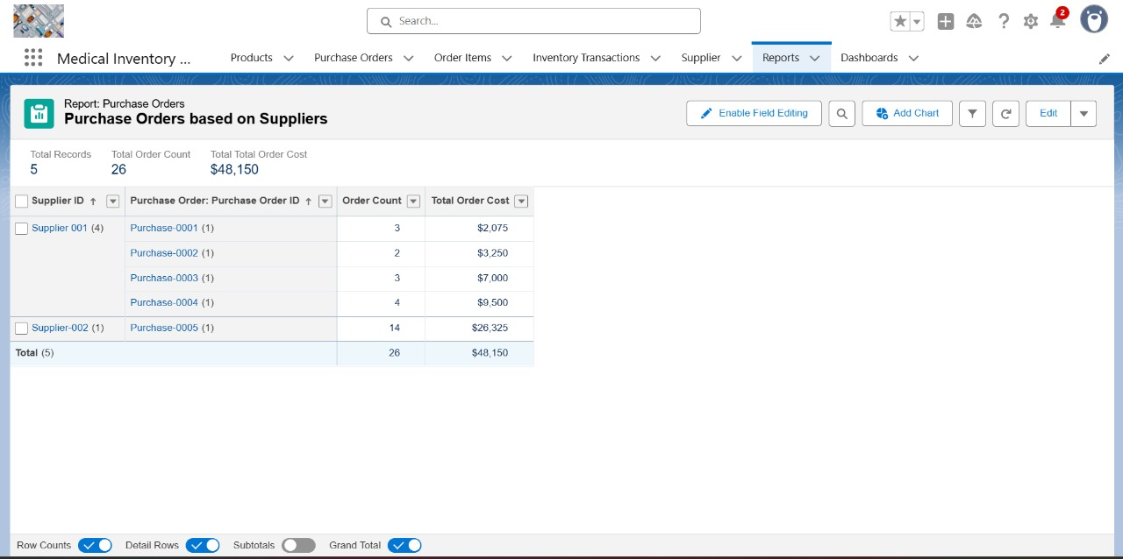

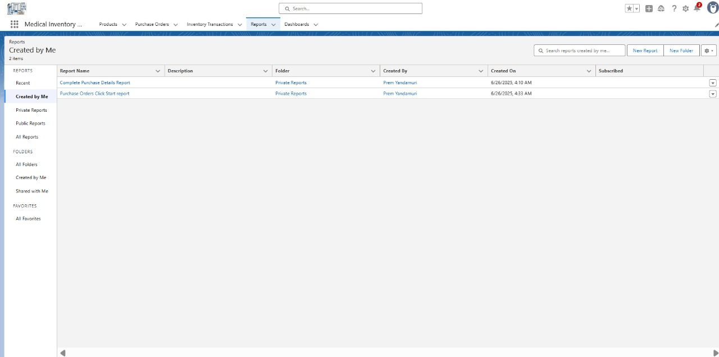

**Dashboards:**

Dashboards in Salesforce are dynamic visual representations of key metrics and data from reports, providing a consolidated view of organizational performance and trends. They are powerful tools for monitoring real-time data, tracking progress towards goals, and gaining actionable insights at a glance. Dashboards consist of components such as charts, tables, metrics, and gauges that display data from underlying reports.

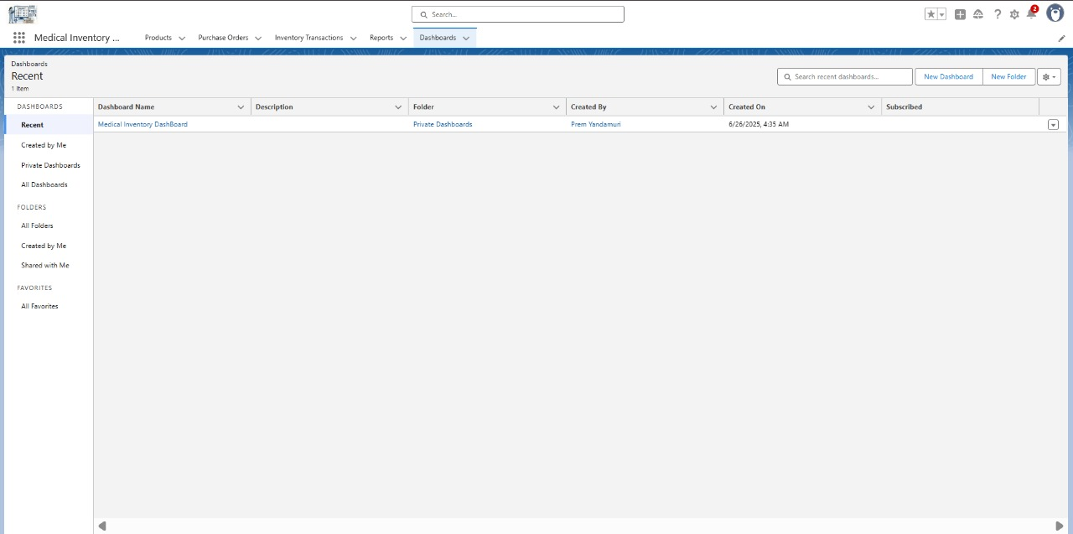

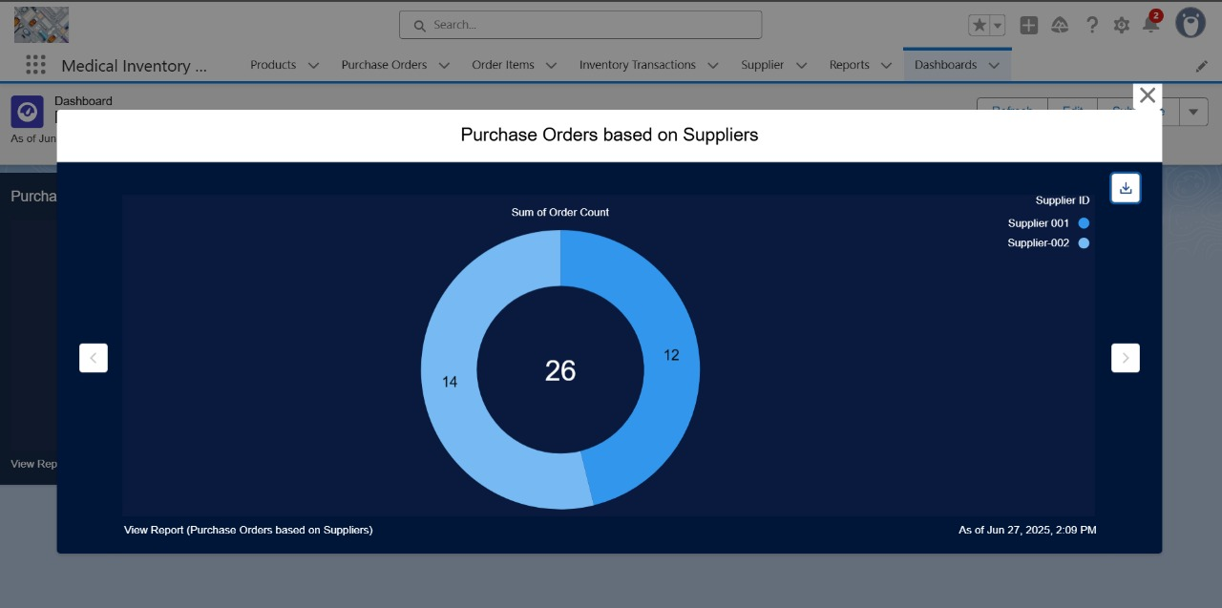

**6. FUNCTIONAL AND PERFORMANCE TESTING**

# Performance Testing:







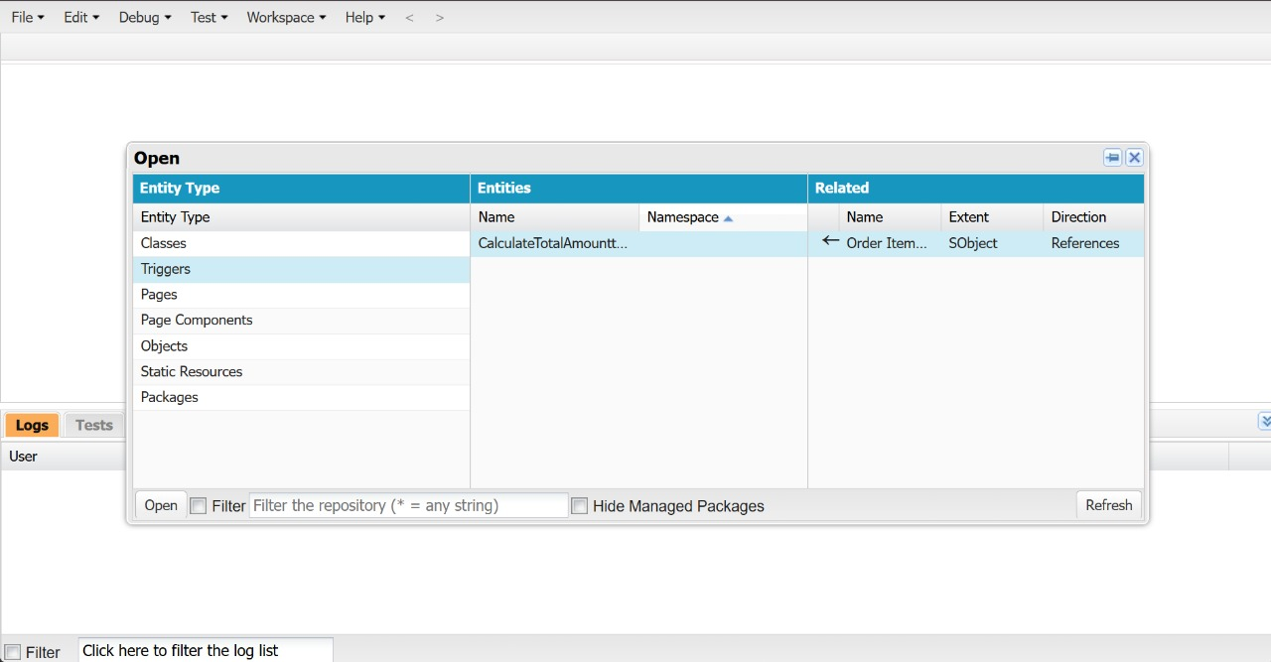

 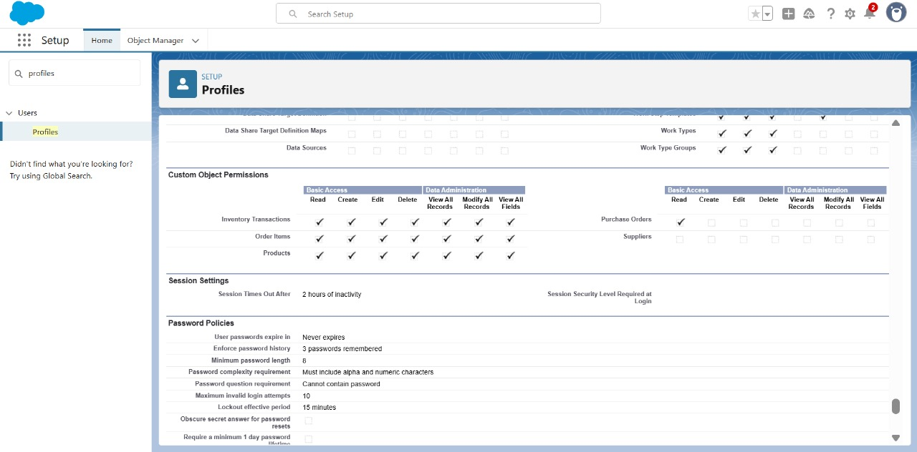



**7. RESULTS**

# **Output Screenshots:**



  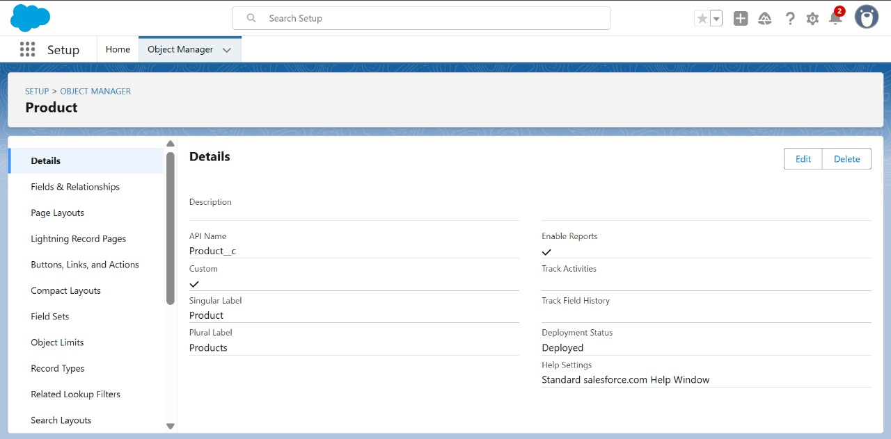     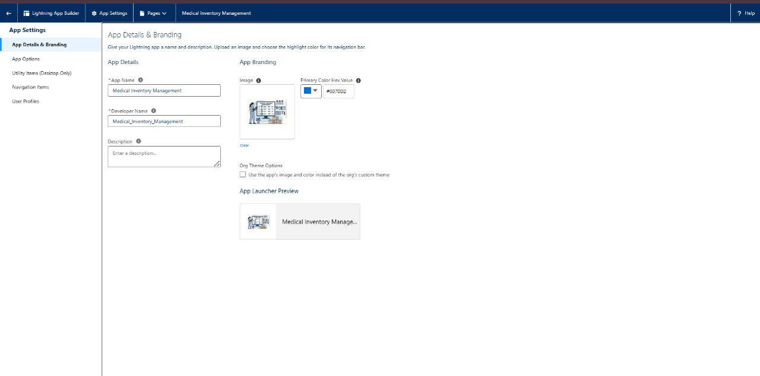  



**8. ADVANTAGES & DISADVANTAGES**

Here are the advantages and disadvantages of a Medical Inventory Management Project:

# **Advantages:**

1. Improved Accuracy:

* Reduces human errors in tracking stock levels, expiration dates, and reordering.

2. Real-Time Tracking:

* Provides live updates on inventory status, improving decision-making and response time.

3. Cost Savings:

* Prevents overstocking and understocking, reducing wastage and unnecessary purchases.

4. Enhanced Patient Safety:

* Ensures that expired or unavailable medicines are promptly identified, reducing risks to patients.

5. Regulatory Compliance:

* Helps maintain accurate records required for audits, certifications, and healthcare regulations.

6. Increased Efficiency:

* Automates repetitive tasks like stock updates and alerts, saving time for healthcare staff.

7. Data-Driven Insights:

* Generates reports and analytics for better forecasting, budgeting, and inventory planning.

# **Disadvantages:**

1. High Initial Setup Cost:

* Investment in software, hardware (like barcode scanners), and staff training can be expensive.

2. System Downtime Risks:

* Technical failures or software downtime can disrupt inventory tracking.

3. Complexity in Integration:

* Integrating with existing hospital management systems may require additional customization and effort.

4. Staff Training Requirement:

* Requires proper training for medical and inventory staff to ensure smooth adoption.

5. Cybersecurity Risks:

* Sensitive medical inventory and patient-related data can be targets for cyber-attacks.

6. Dependence on Technology:

* Heavy reliance on the system might become a problem in case of outages or system failures.

**9. CONCLUSION**

# **Conclusion:**

The implementation of a Medical Inventory Management System is a vital step toward modernizing healthcare operations. It provides a structured and automated solution for managing the complex inventory needs of healthcare facilities, including medicines, medical equipment, and consumables. By offering real-time tracking, automated alerts for low stock and expiration dates, and comprehensive reporting, the system significantly enhances operational efficiency and accuracy. One of the key benefits is the reduction of manual errors, which can lead to serious issues such as stockouts, overstocking, or the use of expired medical supplies. Improved inventory control ensures that the right medical products are available at the right time, directly contributing to better patient care and safety.

Additionally, the system supports regulatory compliance by maintaining accurate records that can be easily accessed during audits or inspections, helping healthcare organizations meet national and international healthcare standards. The ability to generate detailed reports and analytics allows administrators to make data-driven decisions regarding procurement, budgeting, and inventory optimization, leading to long-term cost savings. However, the project is not without challenges. Initial investment costs for software, hardware, and staff training can be substantial. Integration with existing hospital systems may require additional time and technical expertise. There are also cybersecurity concerns, as the system often handles sensitive data related to medical supplies and patient treatments, making it a potential target for cyber threats.

Despite these challenges, the long-term benefits far outweigh the limitations. With proper planning, system maintenance, and staff training, a medical inventory management system can become a powerful tool that streamlines operations, enhances patient safety, improves compliance, and ultimately contributes to the overall effectiveness of the healthcare delivery process.

In conclusion, a well-implemented medical inventory management project is essential for any healthcare facility striving for efficiency, accuracy, and high standards of patient care in the modern medical landscape.

**10. FUTURE SCOPE**

# **Future Scope of Medical Inventory Management:**

The Medical Inventory Management System has vast potential for future growth and development. As healthcare needs continue to evolve, the system can be expanded and enhanced to provide even greater efficiency, accuracy, and integration with emerging technologies. Some of the key future directions and opportunities include:

1. Integration with IoT (Internet of Things)

* Smart shelves, RFID tags, and IoT-enabled sensors can be used to automatically detect stock levels and environmental conditions like temperature and humidity, which are critical for sensitive medicines and vaccines.
* Real-time automated stock updates without manual intervention.

2. Artificial Intelligence (AI) and Predictive Analytics

* AI can be used for demand forecasting, helping hospitals predict future inventory needs based on patient inflow, disease outbreaks, and historical consumption patterns.
* Predictive alerts for possible shortages, stock expiration, and replenishment scheduling.

3. Mobile Accessibility

* Future systems can offer fully mobile applications for on-the-go inventory checks, approvals, and stock updates, improving accessibility for medical staff.
* Real-time push notifications for urgent stock alerts on mobile devices.

4. Blockchain Integration for Enhanced Security

* Blockchain can be used to track the entire supply chain of medical products, ensuring authenticity and reducing counterfeit risks.
* Immutable transaction records can improve traceability and trust.

5. Cloud-Based Solutions

* Moving the system to the cloud will allow scalability, remote access, and centralized data management.
* It will also reduce infrastructure costs and simplify system maintenance.

6. Automatic Supplier Reordering

* Integration with supplier systems to enable automated purchase orders when stock reaches minimum levels.
* Reduces delays in procurement and ensures continuous availability of critical items.

7. Advanced Reporting and Dashboards

* Future systems can offer customizable dashboards and real-time visual analytics to assist hospital administrators in making faster and more informed decisions.

8. Enhanced Cybersecurity Measures

* As more data becomes digitized, stronger cybersecurity frameworks will be essential to protect sensitive medical inventory and patient data from potential cyber threats.

9. Multi-Location and Multi-Branch Inventory Synchronization

* Ability to manage inventory across multiple hospitals, clinics, or warehouses from a single system.
* Supports easy transfer of stock between locations based on demand.

10. Sustainability Tracking

* Future systems can track medical waste, expired items, and promote eco-friendly inventory practices in line with sustainable healthcare goals.